Thomas Plantin
11/07/19

EE 396V – Homework #4

Problem 1:

a)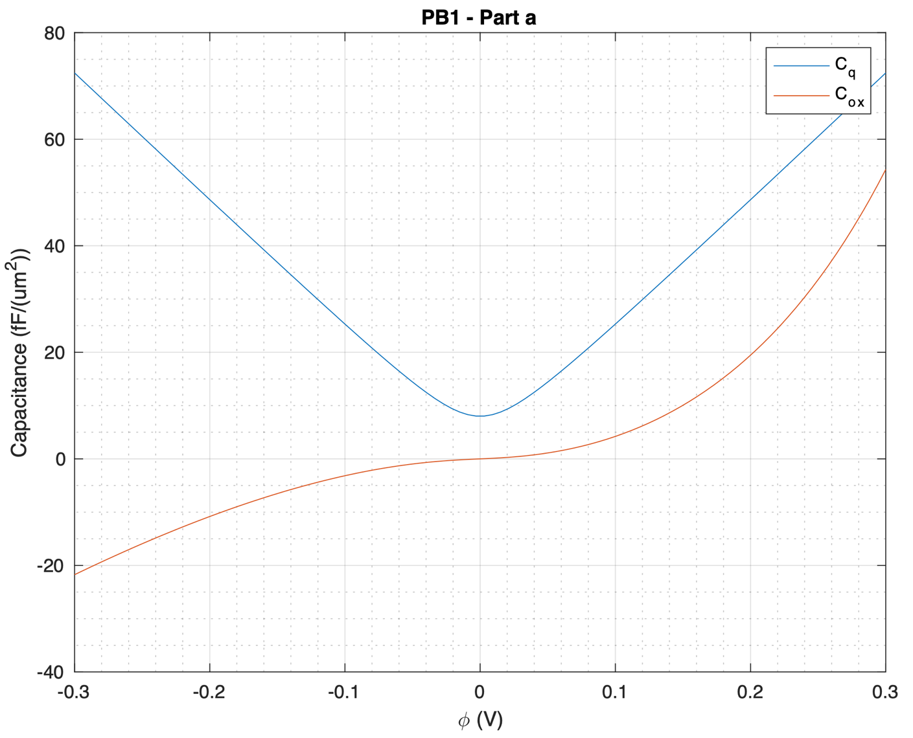
The quantum and oxide capacitances behave differently as the surface potential augments. The quantum capacitance (blue) decreases linearly until it reaches zero, and then symmetrically shoots back up. On the other hand, the oxide capacitance (orange) increases, then flattens out around zero, and then increases again.
b)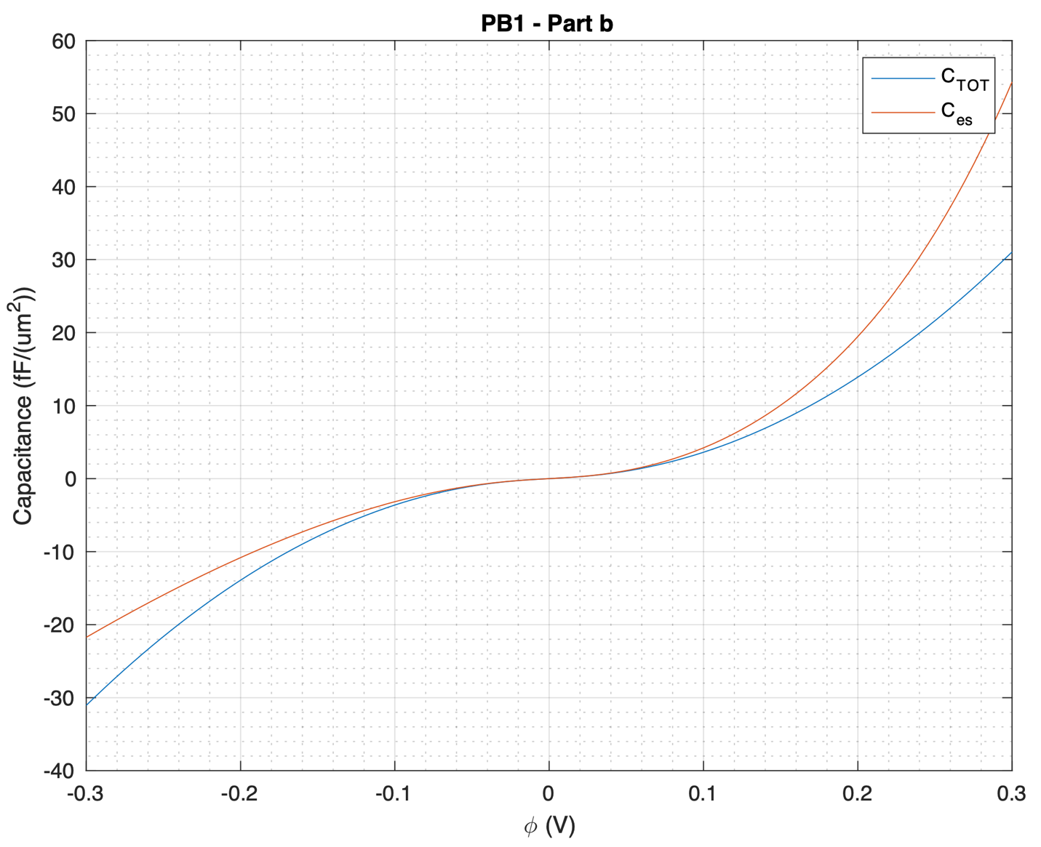
The total capacitance (blue) increases as the surface potential augments. Similar to the oxide capacitance in part a, it also flattens out at zero, and then increases again. The given values show that this is quite interesting for transistor applications.

c) i. The dielectric thickness needed to access the quantum capacitance limit is from 1 to 5 nm. This is not all that practical to incorporate in today’s technology, since realistic transistors have a thickness of about 10nm.

ii. Assuming a higher-k dielectric with a robust thickness of 5 nm, the dielectric constant should be between 3 and 6 to access the quantum capacitance limit.
d) In the limit of a sheet of CNTs, the quantum capacitance of nanotubes approach that of graphene, but it is still greater because of the width of the sheet of nanotubes.

Problem 2:

Problem 3:

- GNRs cannot match the performance of global level copper, unless multiple layers along with proper intercalation doping is used and specular nano-ribbon edge is achieved. However, multi-layer zigzag edged GNRs (zz-GNRs) can be comparable to copper at the local level and can better performance, implying possible application as local interconnects.

Source: Xu, C.; Li H.; Banerjee, K. “Graphene nano-ribbon (GNR) interconnects: A genuine contender or a delusive dream?” 2008 IEEE International Electron Devices Meeting, San Francisco, CA, 2008, pp. 1-4. doi: 10.1109/IEDM.2008.4796651 [Accessed Nov. 8, 2019]

- It is shown that single-walled, double-walled, and multiwalled CNTs can provide better performance than that of GNRs. However, in order to make GNR interconnects comparable with CNT interconnects, both intercalation doping and high edge-specularity must be achieved. Thermal analysis of CNTs shows significant advantages in tall vias, indicating their promising application as through-silicon vias in 3-D ICs.

Source: H. Li, C. Xu, N. Srivastava and K. Banerjee, "Carbon Nanomaterials for Next-Generation Interconnects and Passives: Physics, Status, and Prospects," in IEEE Transactions on Electron Devices, vol. 56, no. 9, pp. 1799-1821, Sept. 2009. doi: 10.1109/TED.2009.2026524 [Accessed Nov. 8, 2019]

- CNTs can carry the highest current density (10⁹ A/cm²), followed by GNRs (10⁸ A/cm²), and finally Cu (10⁶ – 10⁷ A/cm²).

Sources:
Xu, C.; Yang Y.; Brenner, K. “Breakdown Current Density of Graphene Nano Ribbons” [Accessed Nov. 8, 2019]

Murali, R.; Li H.; Banerjee, K. “Graphene nano-ribbon (GNR) interconnects: A genuine contender or a delusive dream?” 2008 IEEE International Electron Devices Meeting, San Francisco, CA, 2008, pp. 1-4. doi: 10.1109/IEDM.2008.4796651 [Accessed Nov. 8, 2019]

- The current challenges that need to be overcome to realize high performance GNRs are to match the performance of copper interconnects without implementing multiple levels and without worrying about using proper intercalation doping.

Source: Xu, C.; Li H.; Banerjee, K. “Graphene nano-ribbon (GNR) interconnects: A genuine contender or a delusive dream?” 2008 IEEE International Electron Devices Meeting, San Francisco, CA, 2008, pp. 1-4. doi: 10.1109/IEDM.2008.4796651 [Accessed Nov. 8, 2019]

Problem 4:
- The value of the speed of light in graphene is 10⁶ m/s (1/300 of the speed of light in a vacuum).

- Kinetic inductance originates in the kinetic energy required by each electron that is contributing to a flow of current.

- Graphene nanoribbon is electronically different from a sheet of graphene because of their difference in geometrical structures.

- Electron scattering occurs when electrons are deviated from their original trajectory. This is due to the electrostatic forces within matter interaction or, if an external magnetic field is present, the electron may be deflected by the Lorentz force.

